**Throw and Throws**

**Throw Keyword**

*The "throw" keyword in Java is used to explicitly throw an exception. It disrupts the normal flow of the program by transferring control to the nearest catch block that can handle the thrown exception. When an exception occurs within a method, the method creates an exception object and throws it using the "throw" keyword*.

***Example 1***

***public class TestThrow {***

***//defining a method***

***public static void checkNum(int num) {***

***if (num < 1) {***

***throw new ArithmeticException("\nNumber is negative, cannot calculate square");***

***}***

***else {***

***System.out.println("Square of " + num + " is " + (num*num));***

***}***

***}***

***//main method***

***public static void main(String[] args) {***

***TestThrow obj = new TestThrow();***

***obj.checkNum(-3);***

***System.out.println("Rest of the code..");***

***}***

***}***

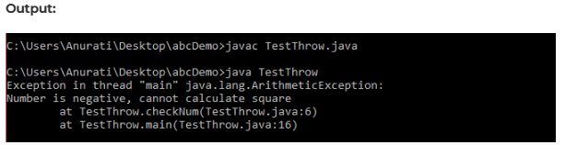

**throws Keyword**

*On the other hand, the "throws" clause is used in method signatures to indicate that the method may throw certain types of exceptions during its execution. It doesn't actually throw the exception; instead, it declares that the method may throw exceptions of specified types, thereby alerting the caller to handle them appropriately*.

**Example 2**

***public class TestThrows {***

***//defining a method***

***public static int divideNum(int m, int n) throws ArithmeticException {***

***int div = m / n;***

***return div;***

***}***

***//main method***

***public static void main(String[] args) {***

***TestThrows obj = new TestThrows();***

***try {***

***System.out.println(obj.divideNum(45, 0));***

***}***

***catch (ArithmeticException e){***

***System.out.println("\nNumber cannot be divided by 0");***

***}***

***System.out.println("Rest of the code..");***

***}***

***}***

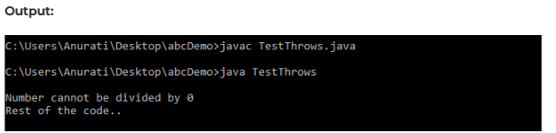

## 

**Conclusion**

*In conclusion, understanding the distinction between "throw" and "throws" in Java is essential for effective exception handling. While both keywords play significant roles in managing exceptions, they serve different purposes and are used in distinct contexts. The "throw" keyword is utilized to explicitly throw exceptions within methods or blocks of code, disrupting the normal program flow and transferring control to the nearest catch block.*

*On the other hand, the "throws" keyword is employed in method signatures to declare the types of exceptions that a method may throw during execution, providing a mechanism for the caller to handle potential exceptions appropriately.*